Capital asset inventory report instructions:
Purpose: this reporting tool is designed for campus users to see basic capital asset record information. For more in depth information or additional reporting tools, contact Property Management.
Click the link to
Multi Organization Equipment Report – Excel
*note that all CSU entities are available in this report so if you would like to see asset under the Board of Governors, select BG under COA codes, if you want to see assets under CSU Pueblo, select PB under the COA codes. Otherwise it will default to CSU Fort Collins= CO.
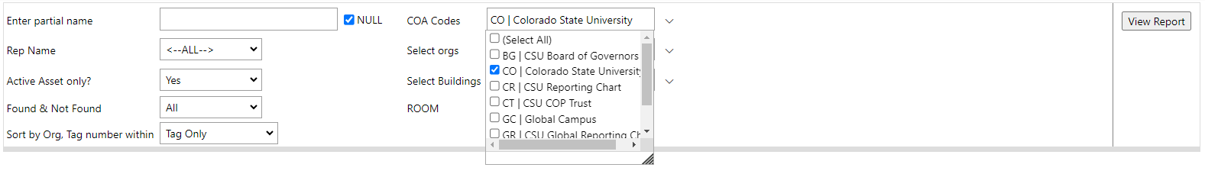

Select from the drop down
Department Organization Code:
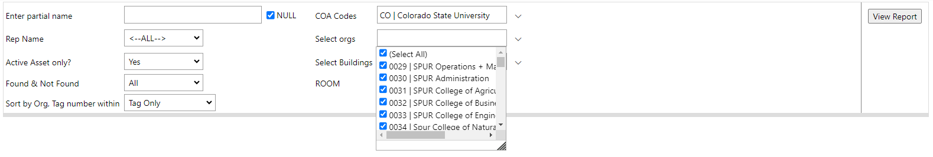
and or Building(s):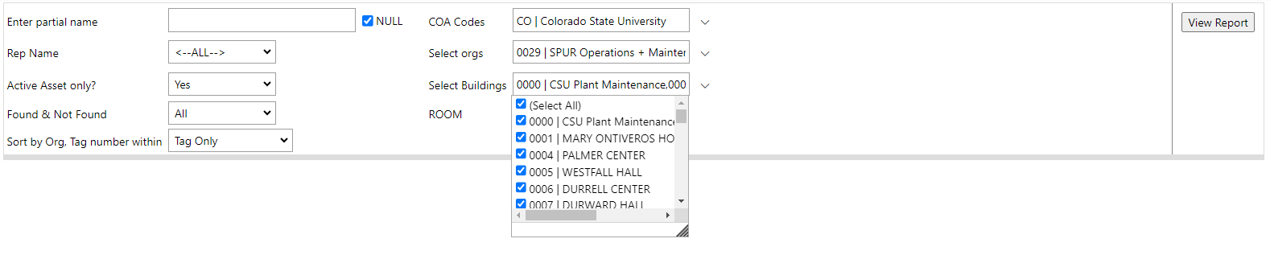
and or Rep Name:
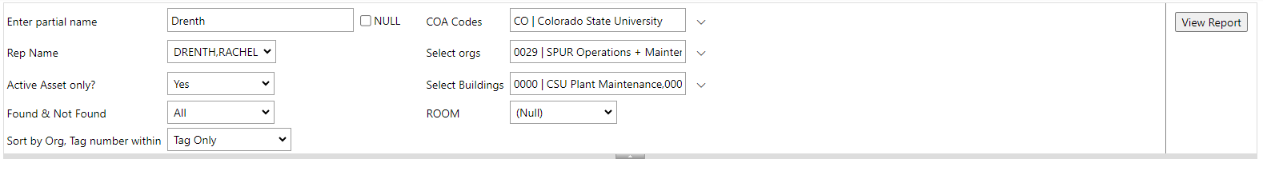

Then click View Report on the far right.
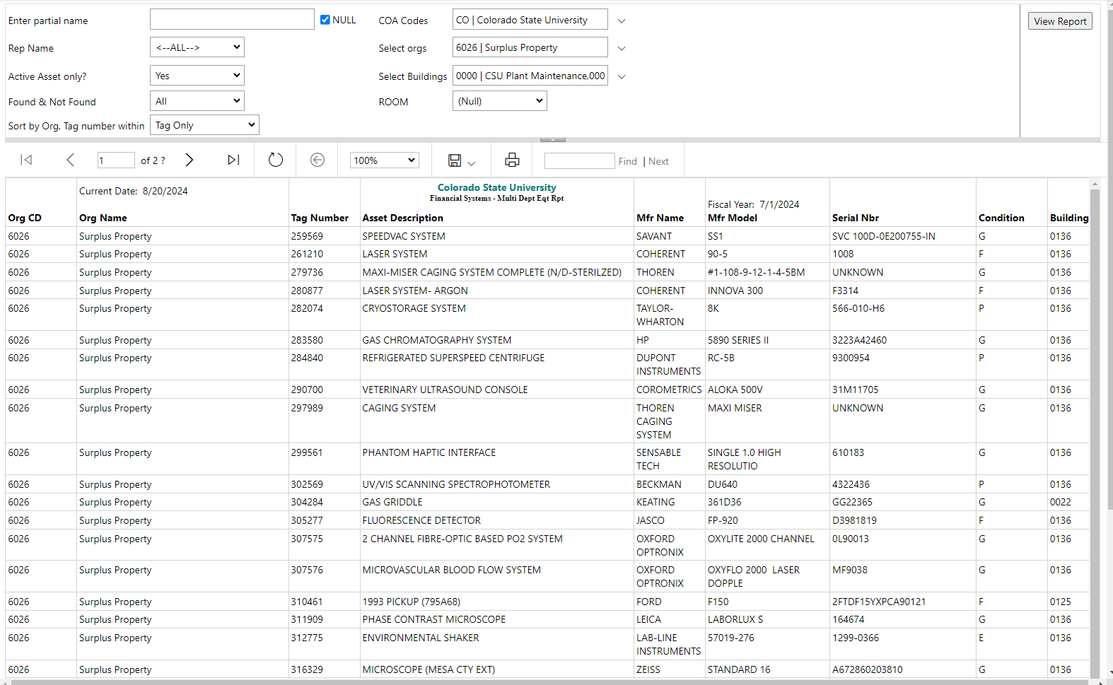

You can now export into whichever format you prefer (it is optimized for excel) or print the report.
